### **TIS2151 WEB APPLICATION DEVELOPMENT**

**Trimester 1, 2022/2023**

**Lecturer: Khairil Imran Bin Ghauth**

**Project Title: Game System**

### 

| **Student ID** | **Project Members** |
| --- | --- |
| **1171101456** | **Eugene Lee Choon Meng** |
| **1201302552** | **MOHAMMAD SHAHRULAZWAN BIN MOHD SHAFIRI** |

### **Introduction**

#### Project Overview

This project explores ways to see how a dynamic multi-user environment works. For instance, how to detect if the other user input a message into a chat system? How to determine if the users are offline or online? Or if a user is matchmaking, etc. As such, this project uses ajax and database to solve these issues . Because php is a server side script, meaning that they cannot see what the user is doing and cannot tell how the user is doing as well. One way to pass data from one user to another is to use a database, and to check up on the user, querying the user periodically is a way to achieve it. For example, creating a live chat, matchmaking system or a game system such as rock paper scissors. User 1 doesn’t know that User 2 performed an action. To solve this problem, one can query both the user intervally to check and refresh the data.

This project also seeks to reverse engineer some generic login and signup systems. Specifically, checking if username/email is taken, or if the details entered are in the correct format, etc in run time; without requiring the user to reload the page every time. In addition to checking if the user has already logged in and creating a dynamic page. Furthermore, the admin functions are inspired by phpMyAdmin. In particular, auto generation of the table, creating a text area to edit when double clicking and also deleting the table rows, all during runtime.

#### Problem Statement

Php is a server side scripting language. In a sense, it serves data. But they don’t know what the user is doing. Additionally, javascript cannot pass a variable directly to php since php is at server side, and javascript is at the client side; server side don’t know what is happening in client side. Moreover, using the post or get method in the same page as the form requires the user to refresh the page to create or update a resource. Meaning that for every form the user submits a form, the page is required to reload so that the data can be processed and retrieved.

#### Objectives

* To study ways to detect user input
* To explore way to pass and retrieve data between users without reloading the page
* To design a web application and create a multiplayer game with live chat, matchmaking and login & signup system
* To learn more about ajax and web development

#### Scope

* Create a login system
* Create a signup system
* Create a chat system
* Create admin function such as view, edit and delete table
* Create a matchmaking system
* Create a game system, such as rock paper scissors
* Create a game system that connects two player
* Use ajax to prevent the page from reloading every time the user submits a form
* Use HTML and CSS to create page
* Create a dynamic web page
* Use php and mysqli to pass and retrieve data from the database
* Develop the web application using XAMPP and visual studio code
* Create a dark theme for desktop

### **System & Storage Design**

#### Use case diagram

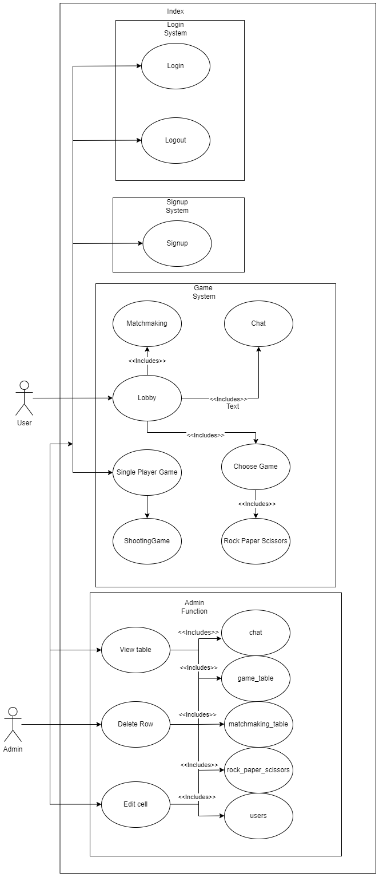

#### Data flow diagram

##### Level 0

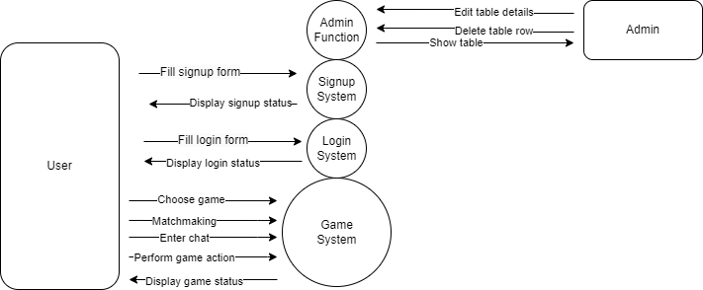

##### Level 1

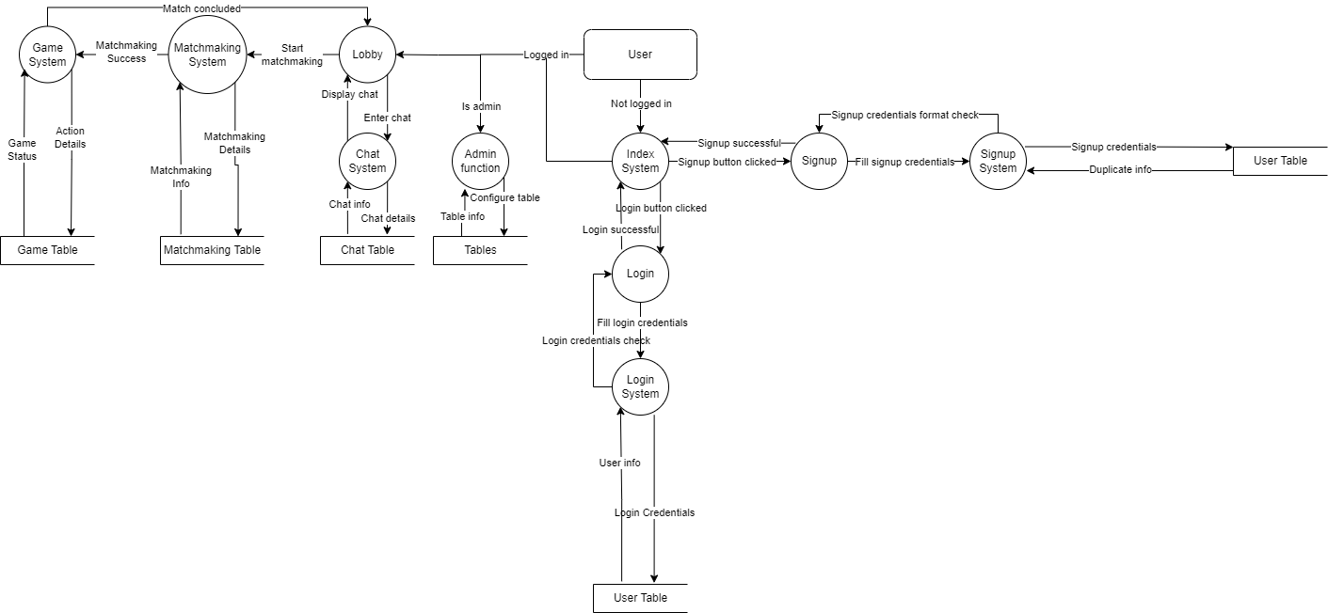

#### Sequence diagram

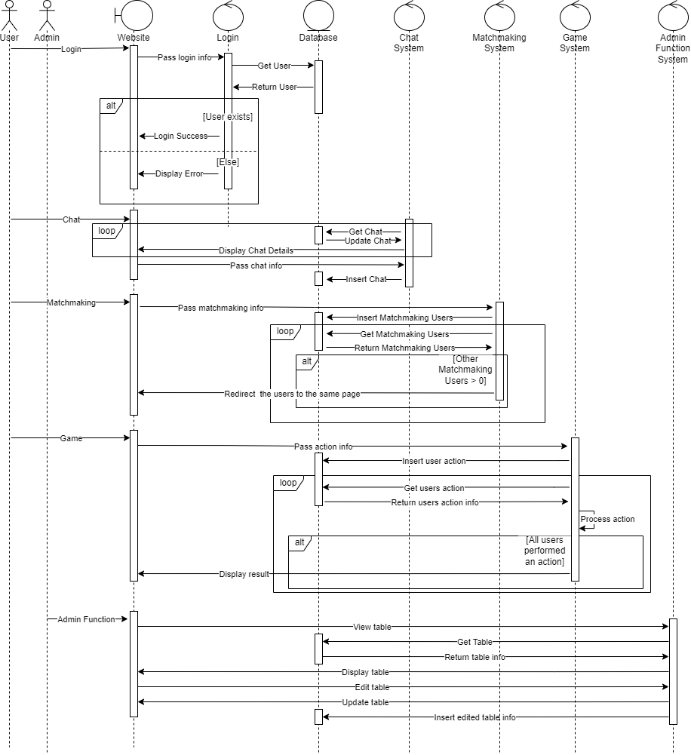

#### Website wireframe and website flow

##### index.php

###### Not Logged In

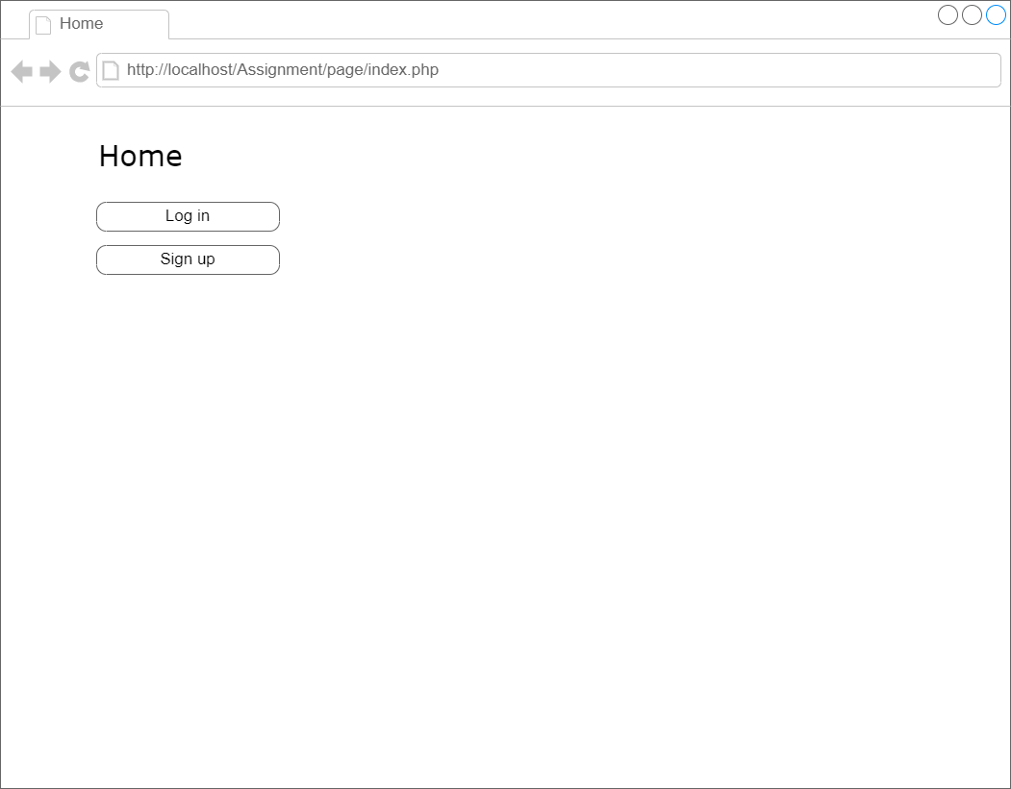

###### Logged In(User)

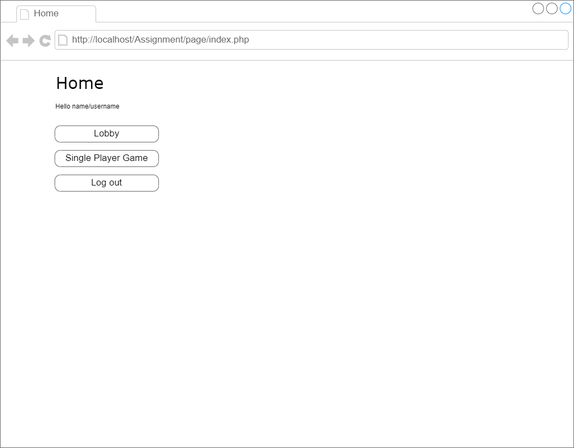

###### Logged In(Admin)

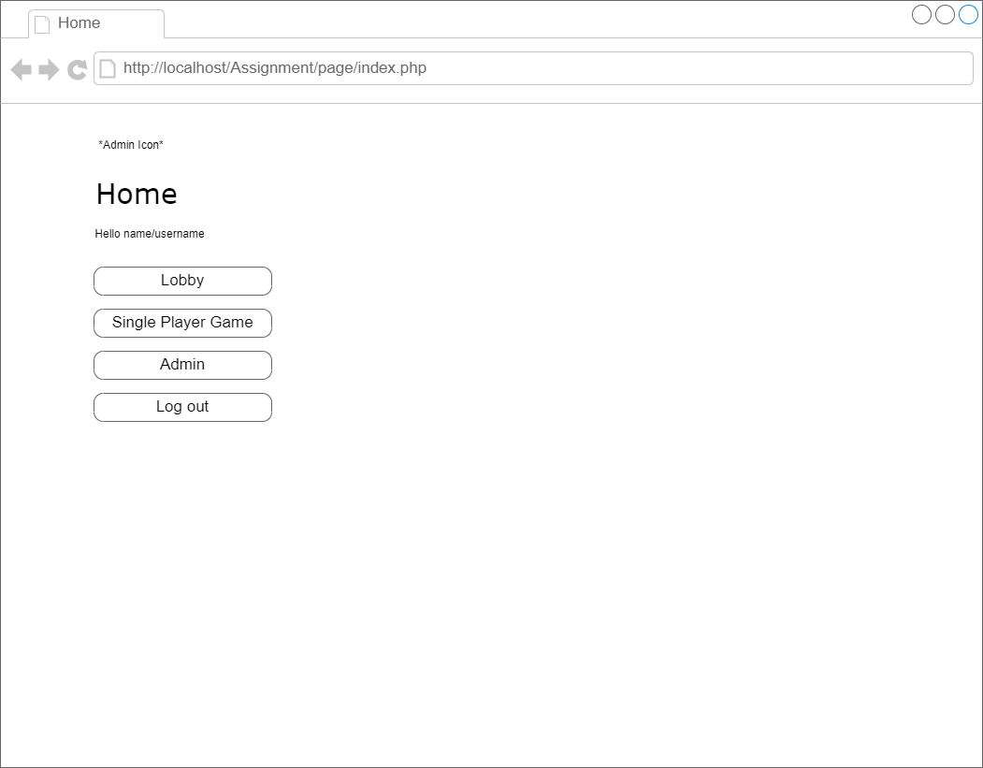

##### login.php



##### signup.php

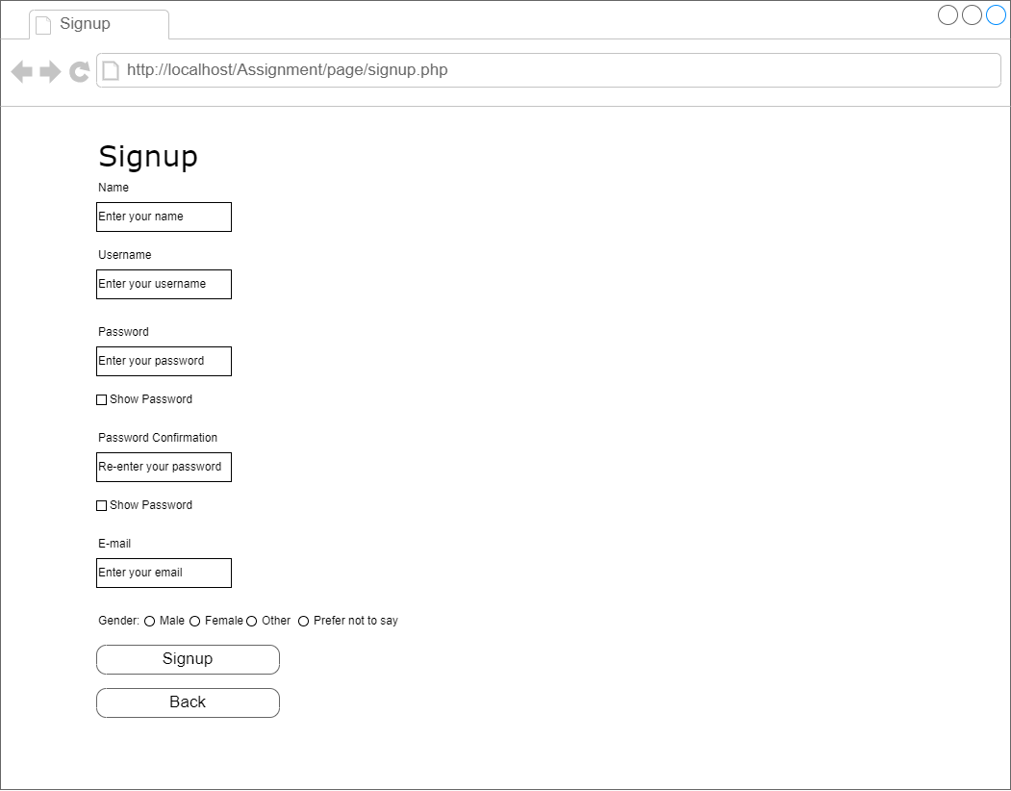

##### lobby.php

###### Not Matchmaking

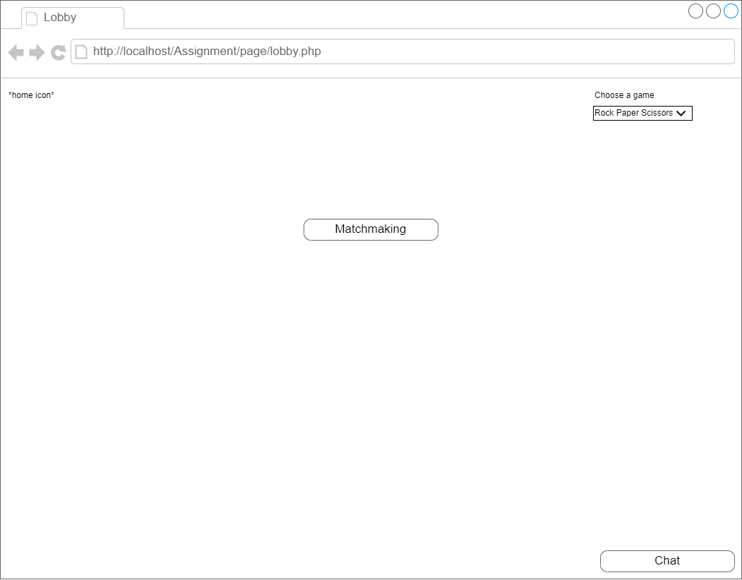

###### Matchmaking

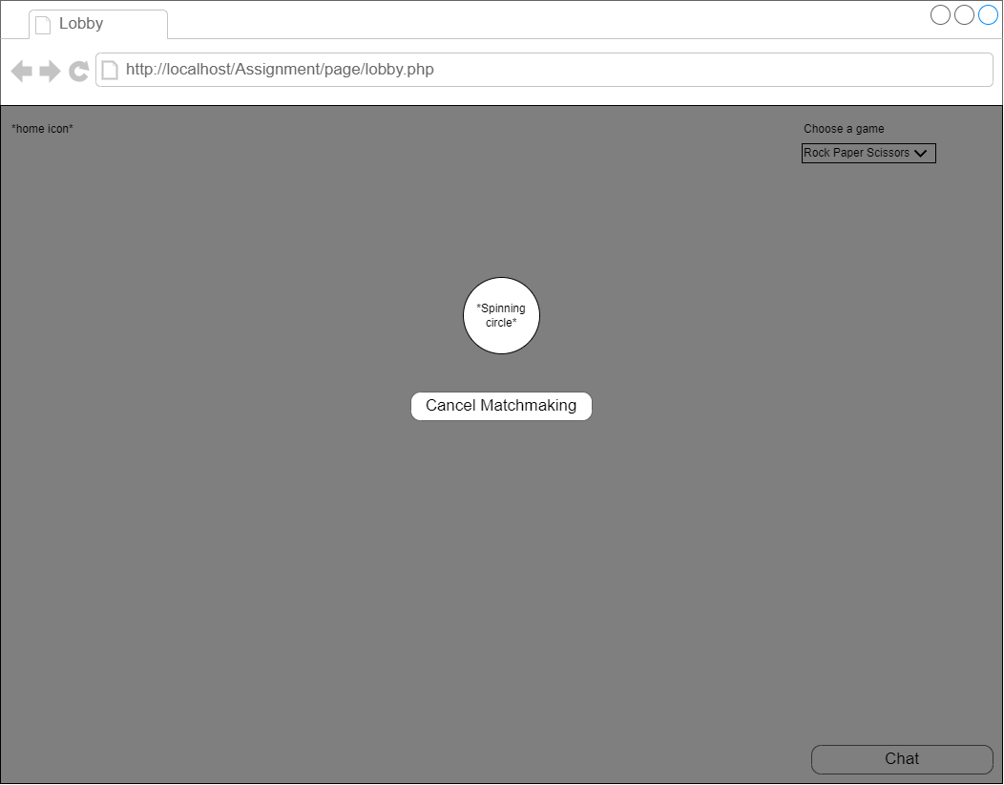

##### admin.php

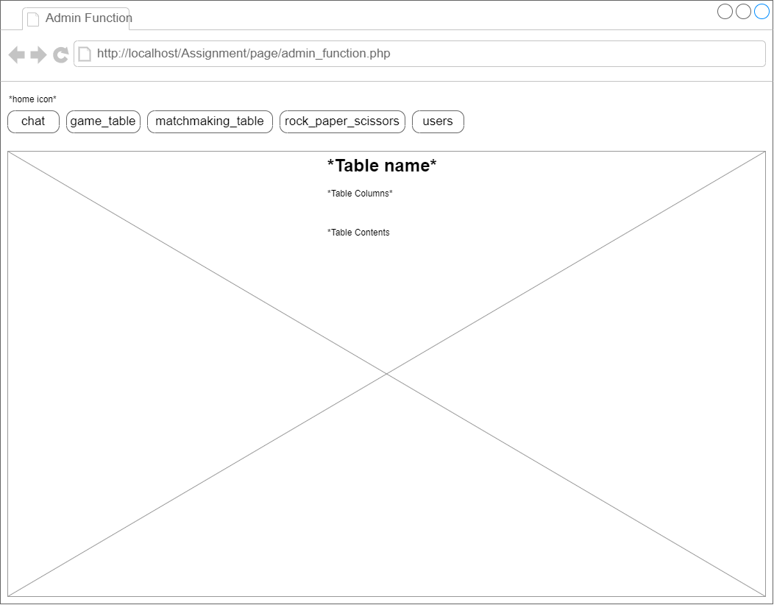

##### rock_paper_scissors.php

###### Player hasn’t made a move

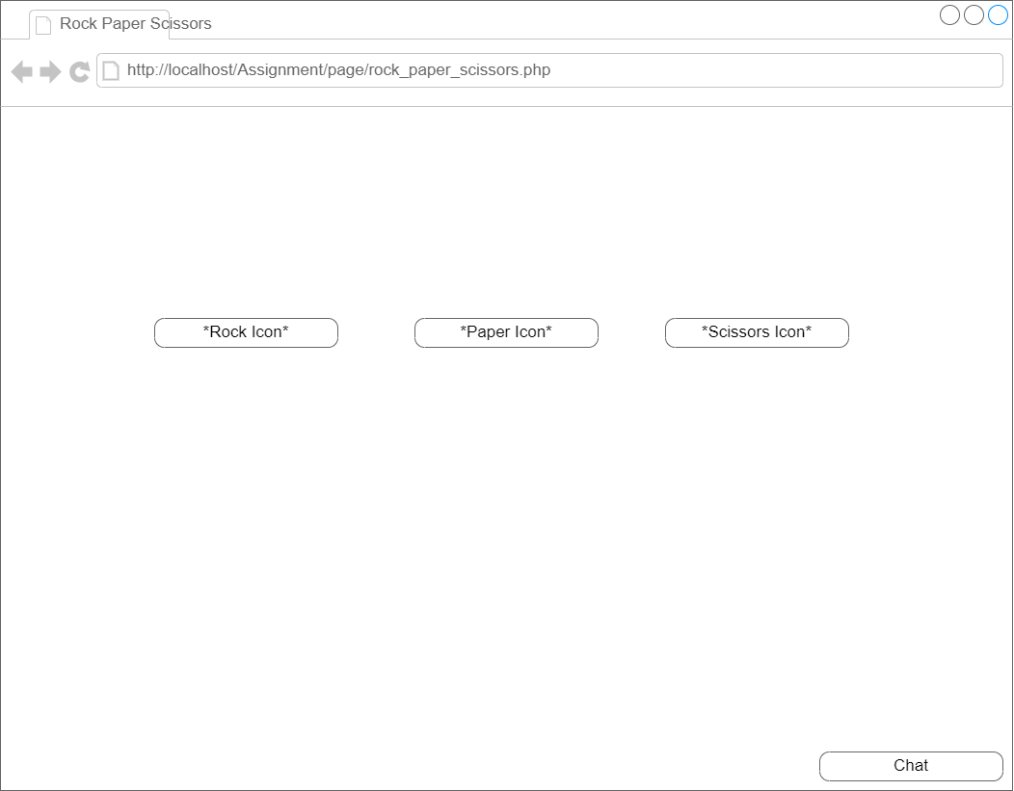

###### Waiting for the other player to make a move

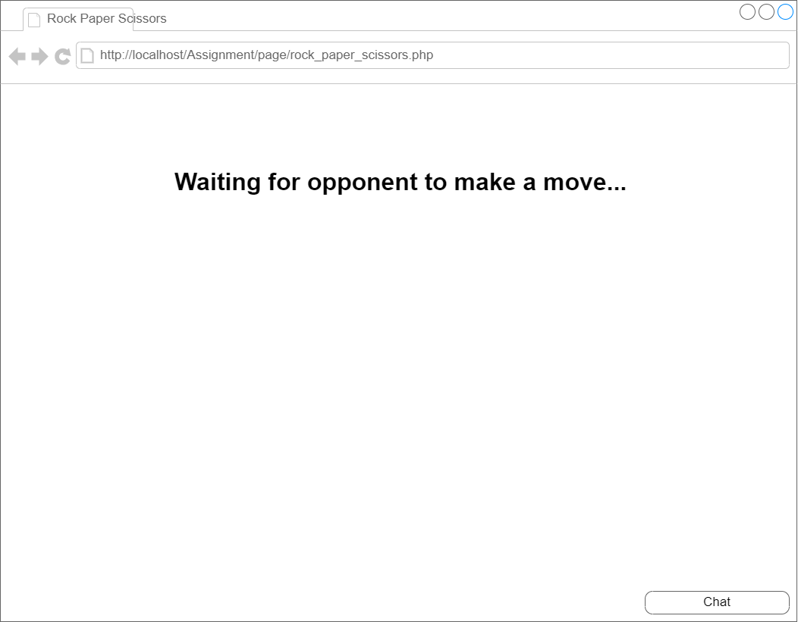

###### Display player won/lose

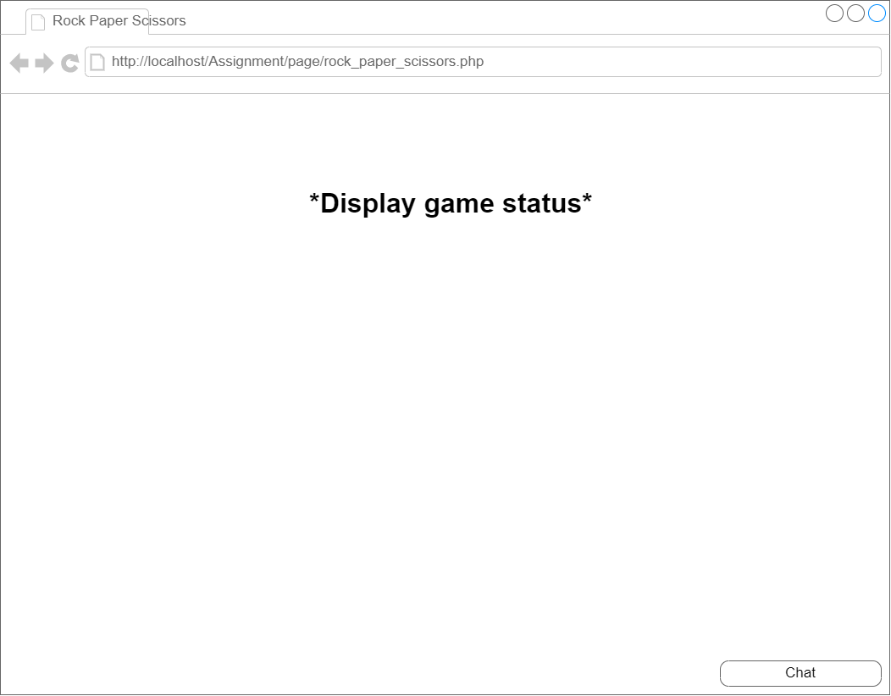

ShootingGame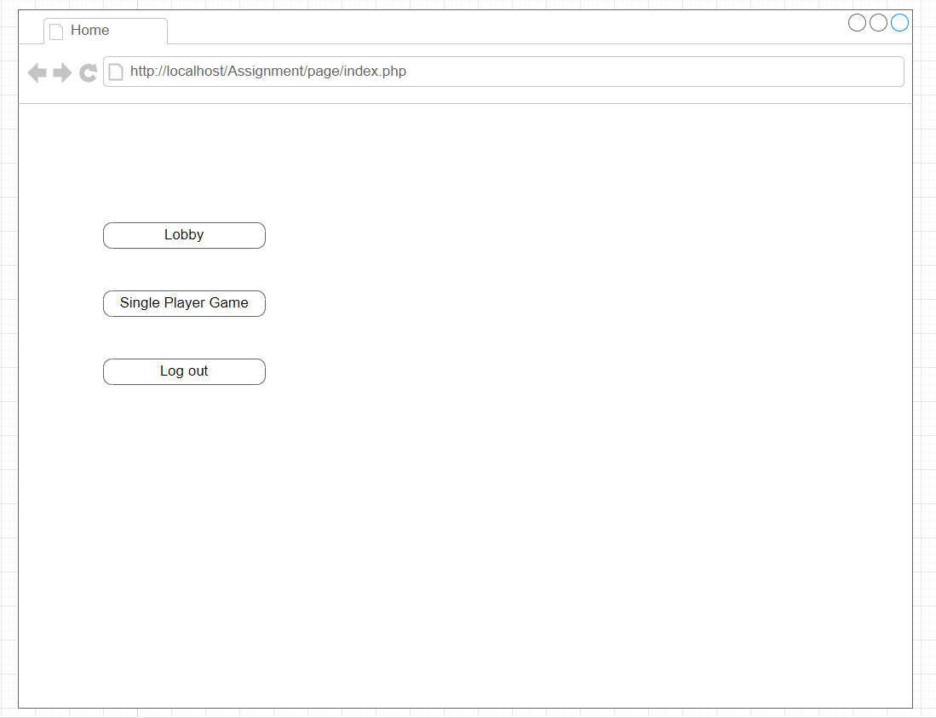

Show main Page

Show initial state of the game page.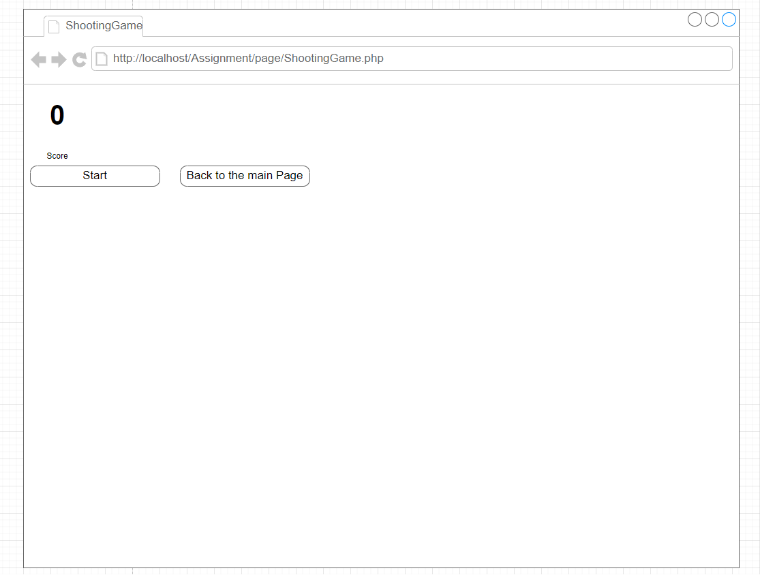

After clicking start, the game will start with random velocity of the target (green circle). Players(blue circle) need to aim and shoot targets to get a point. Projectiles(red circle) have fixed velocity.The game has a time limit which is 30 seconds.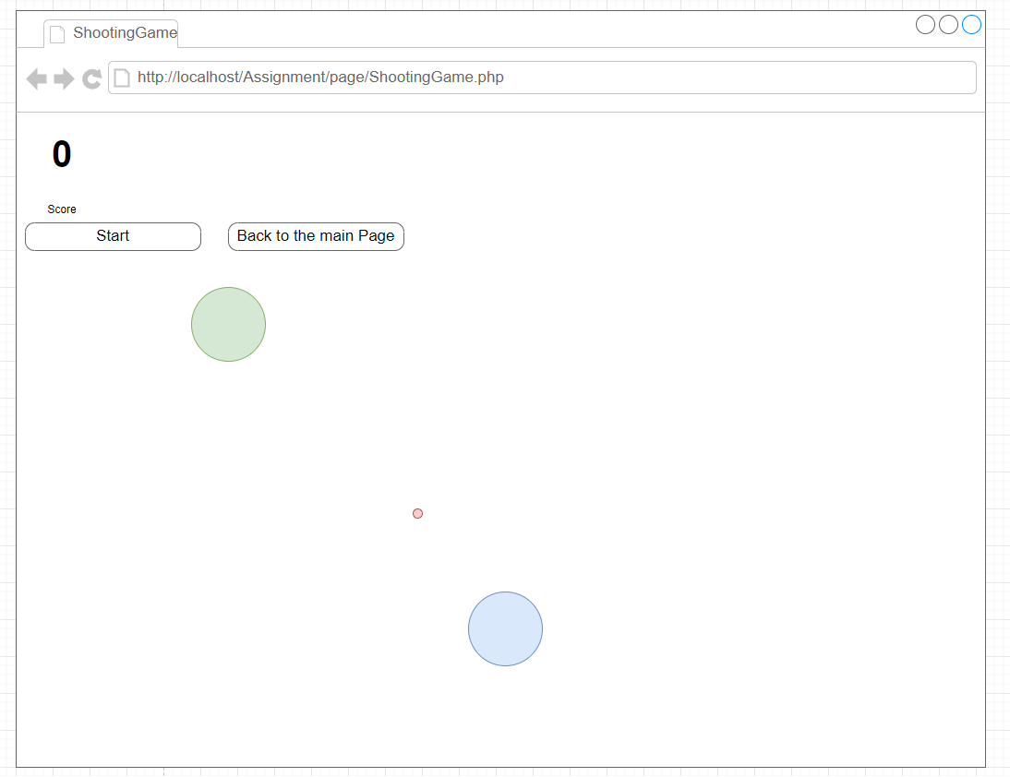

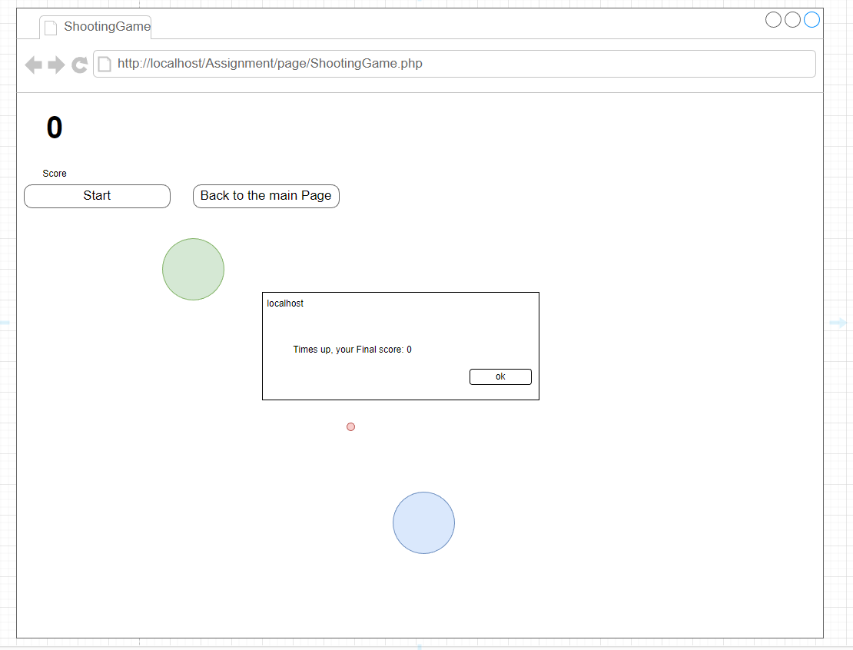

The game will prompt players' final score after times up.

#### ER-Diagram

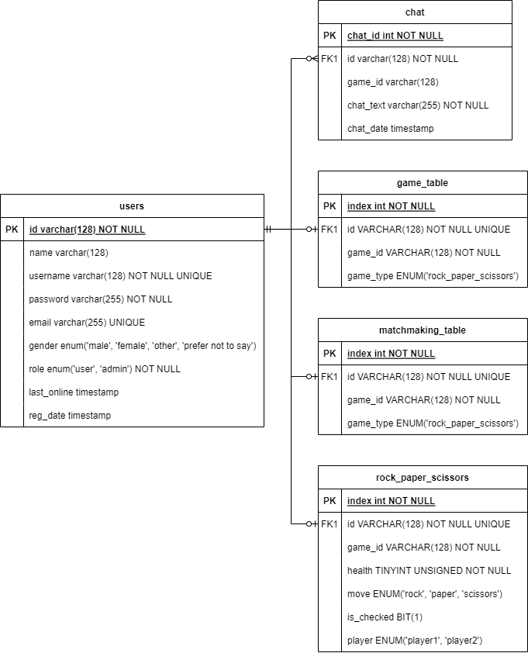

### **Testing**

#### index.php

##### Not Logged In

#### 

##### Logged In (User)



##### Logged In (Admin)



#### login.php

###### User entered wrong credentials







##### 

#### Signup.php

###### User did not enter all the required fields



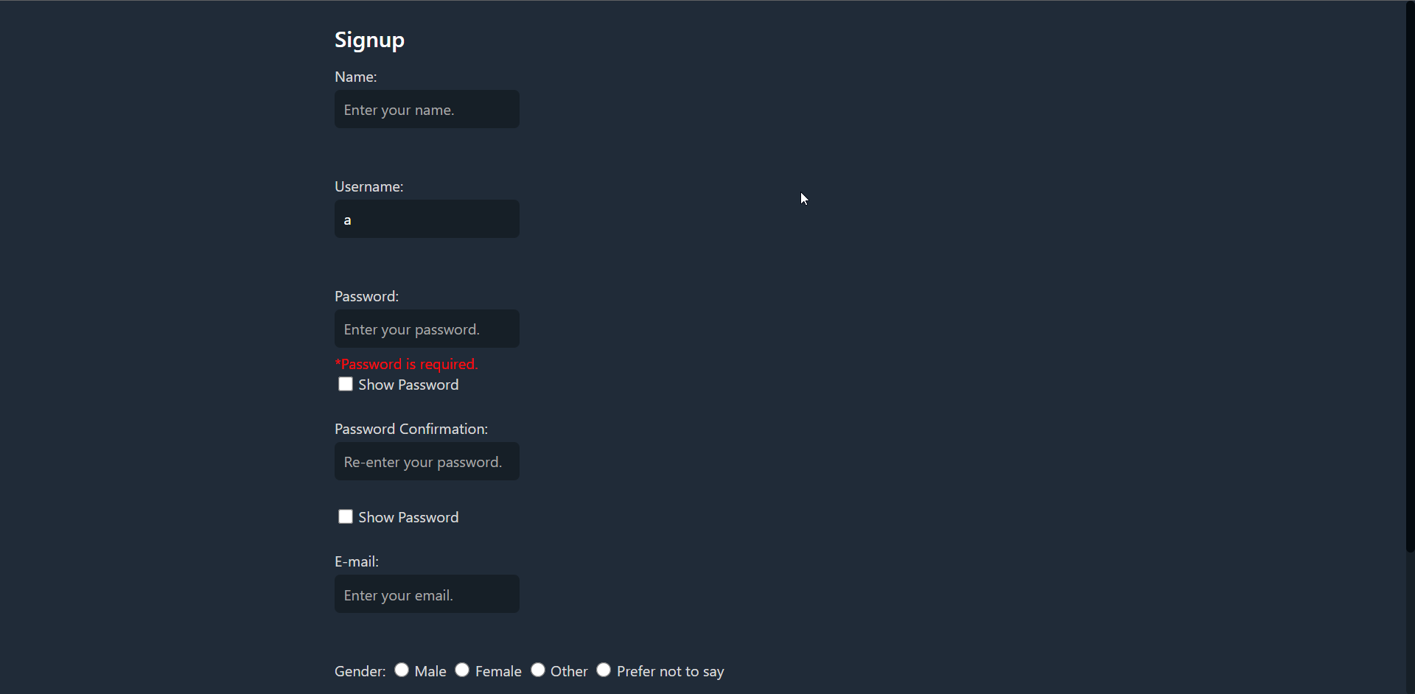

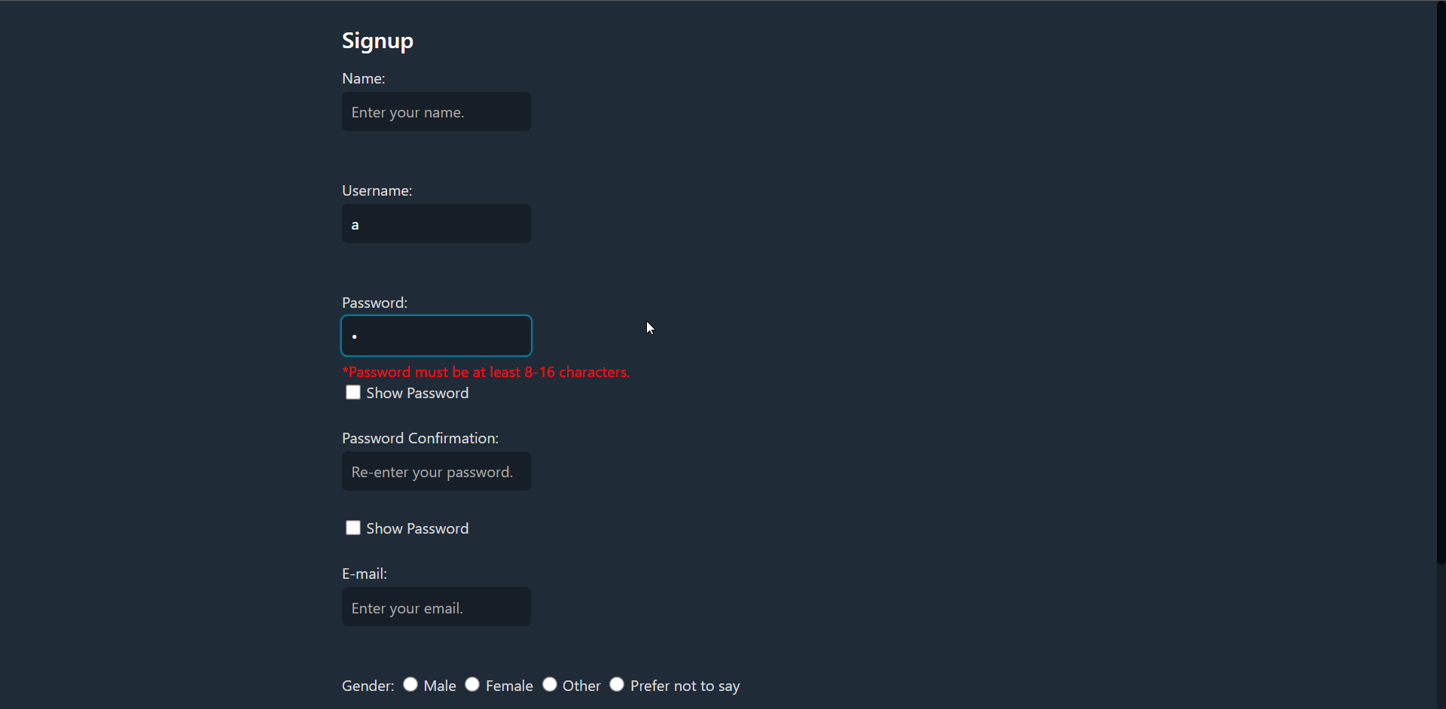





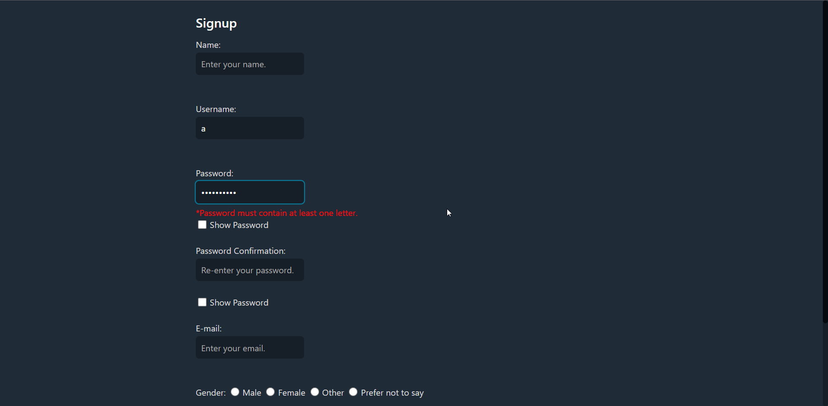

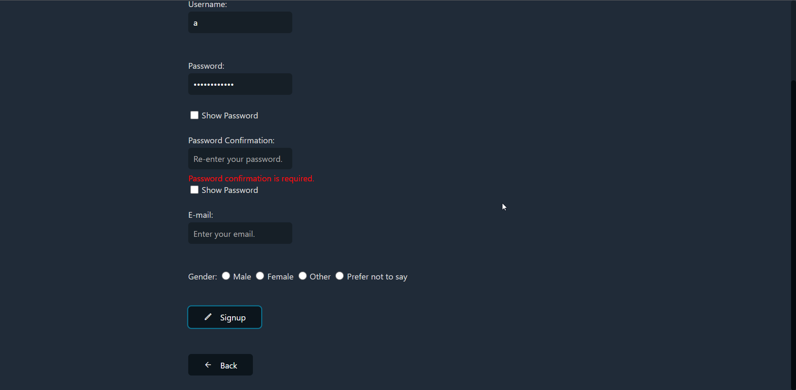

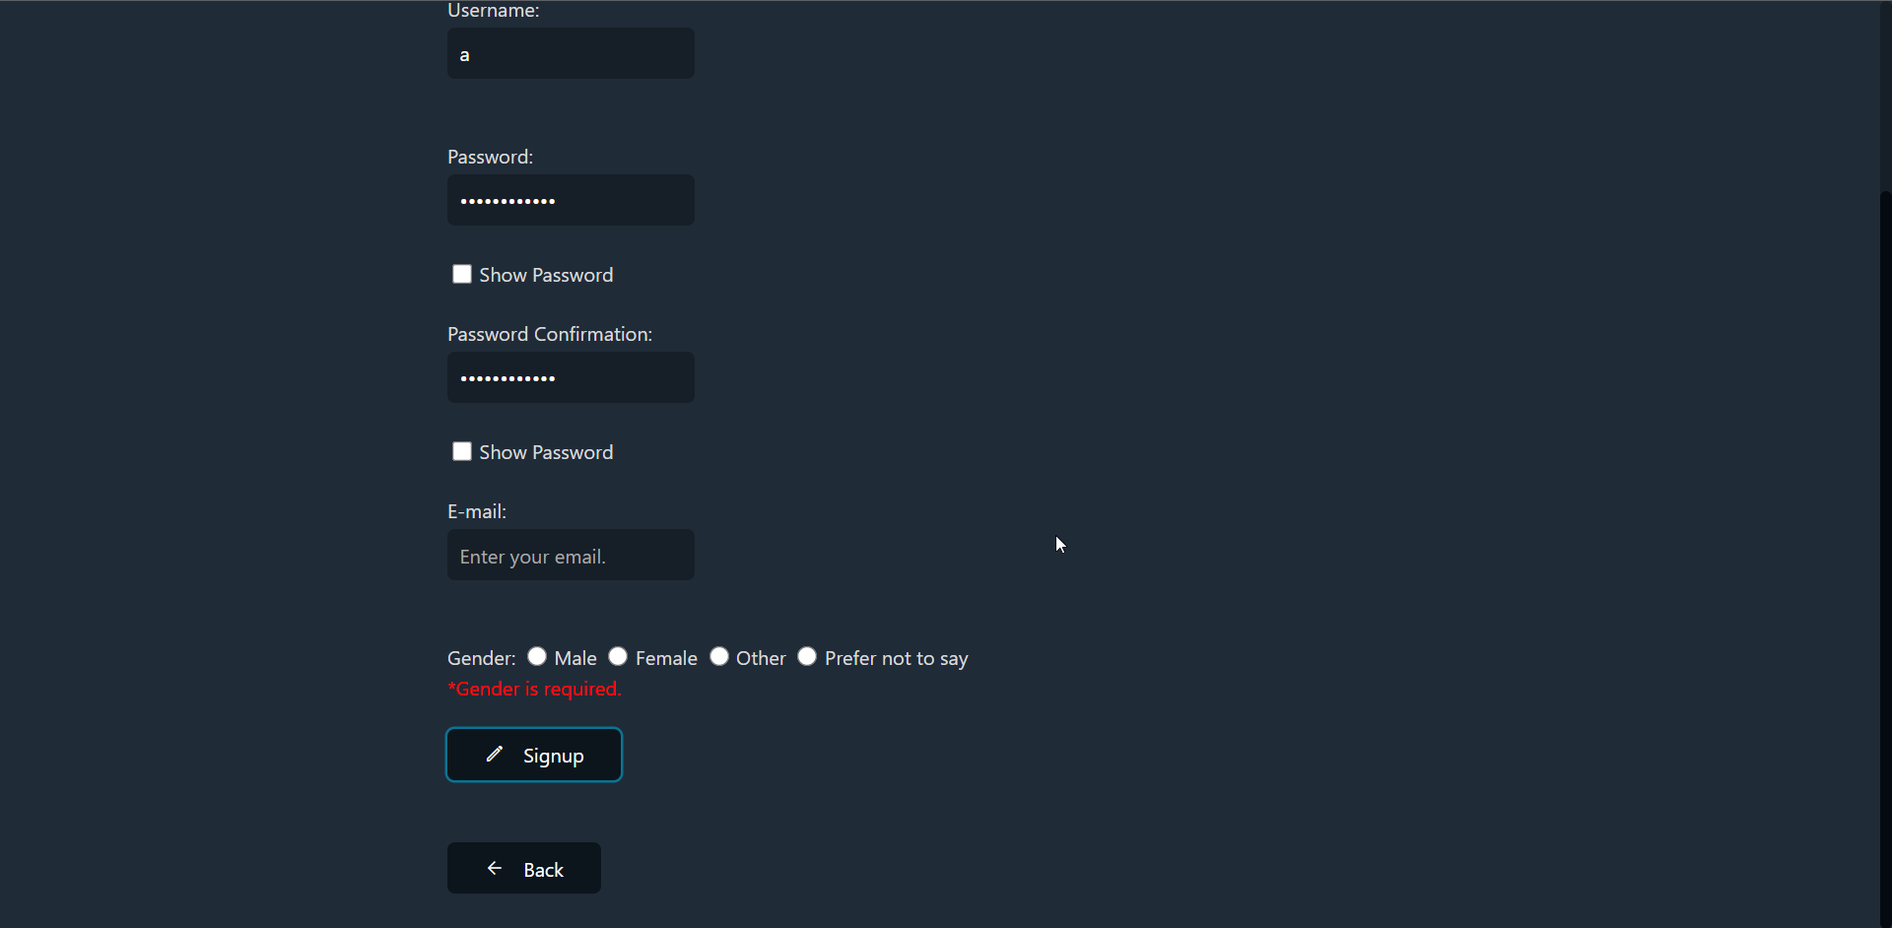

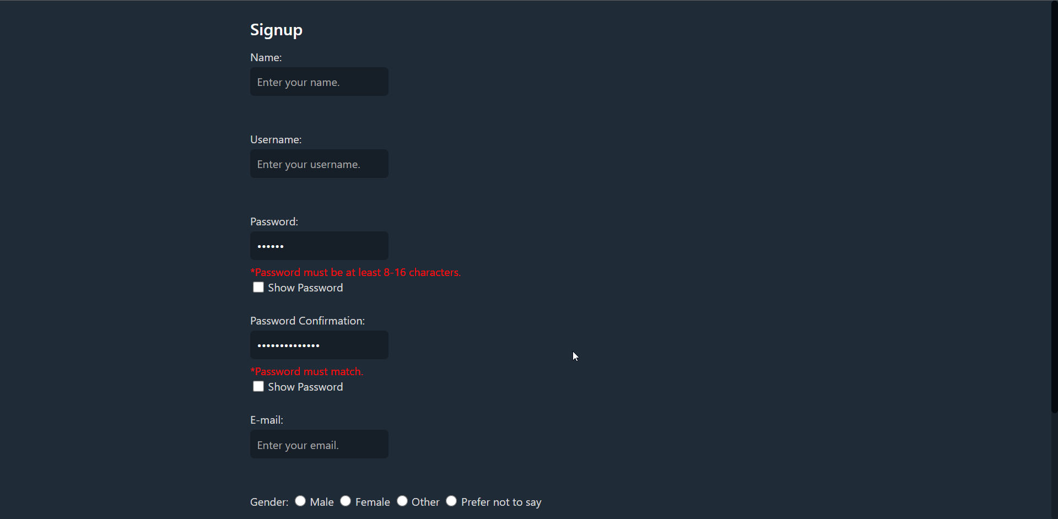

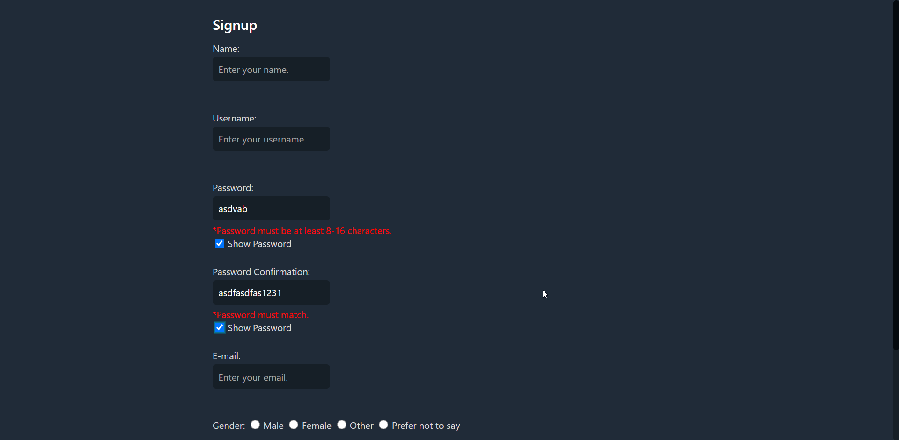

#### admin_function.php



##### chat

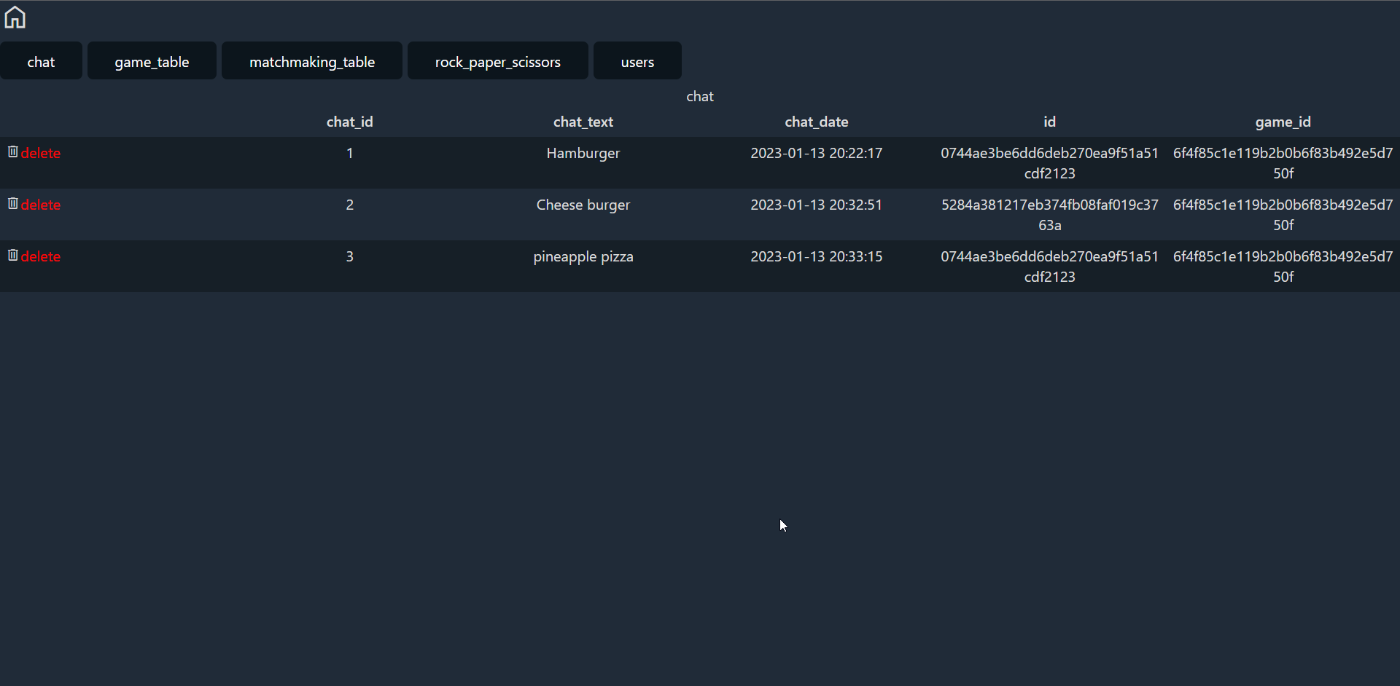

##### game_table

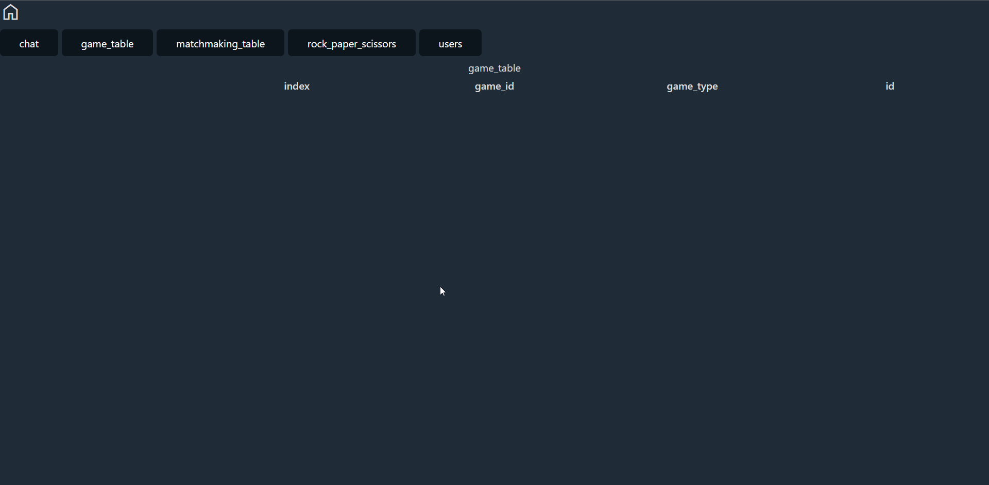

##### matchmaking_table

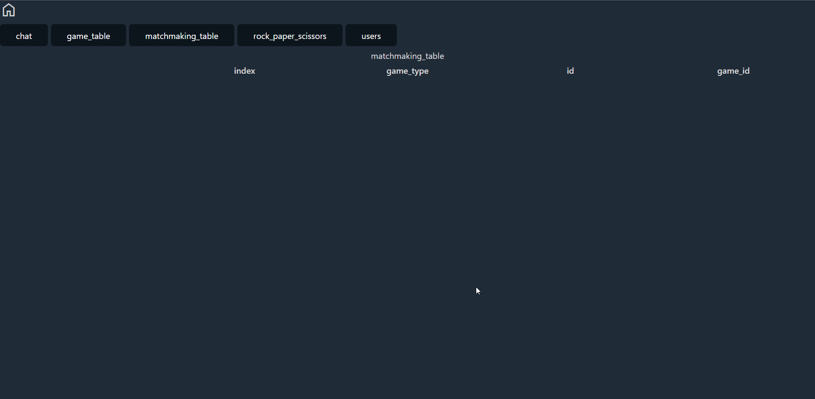

##### rock_paper_scissors

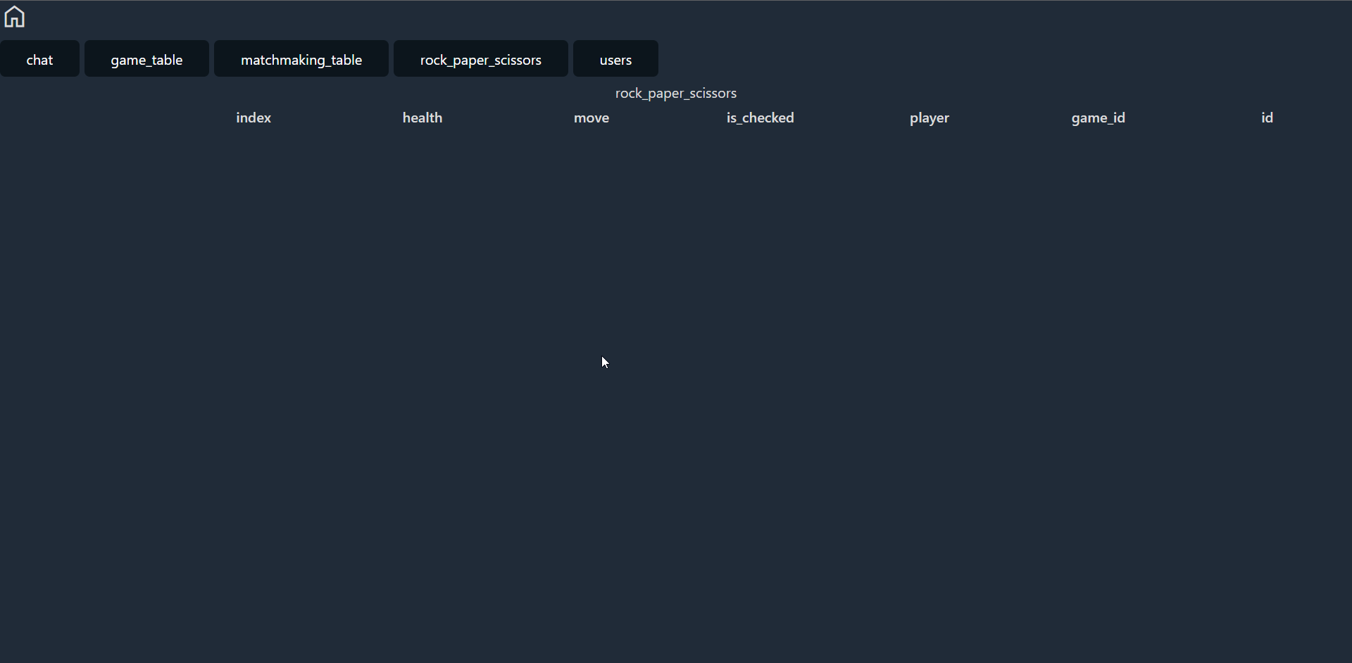

##### users

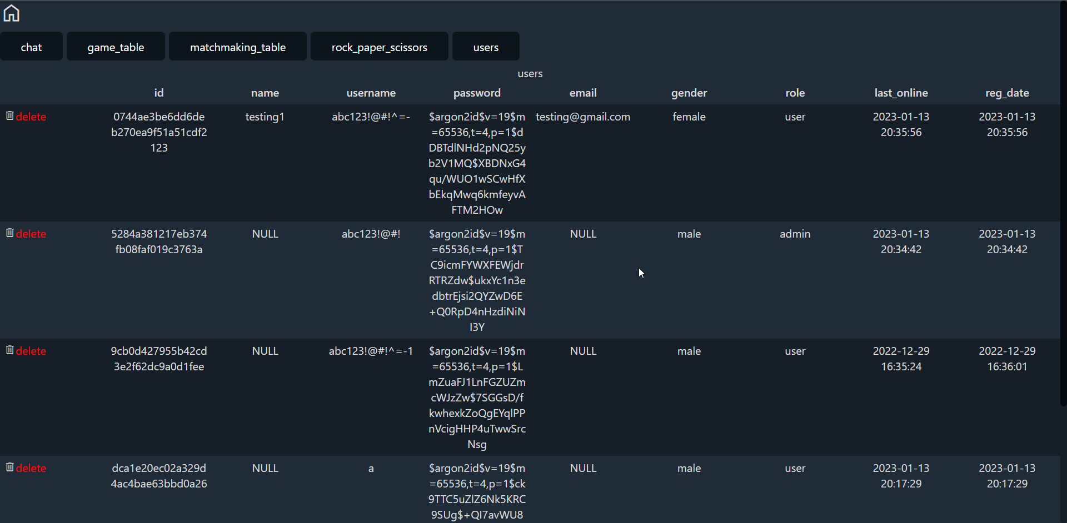

##### editing table

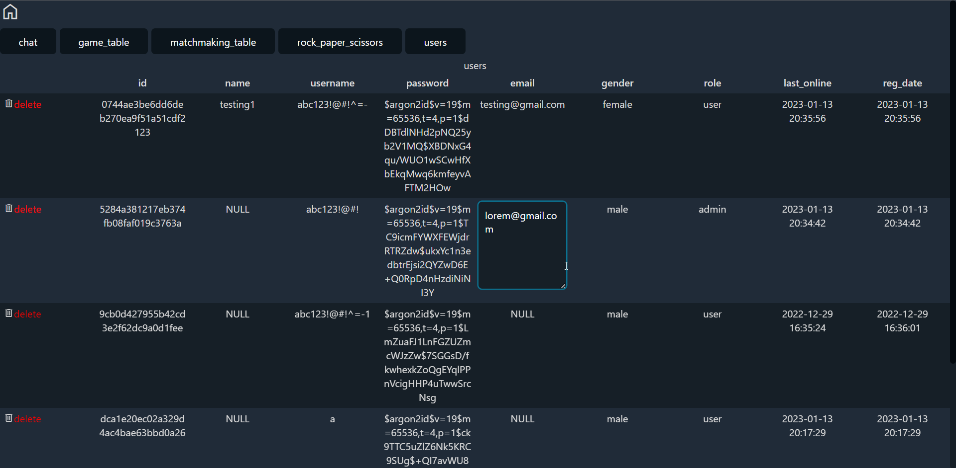

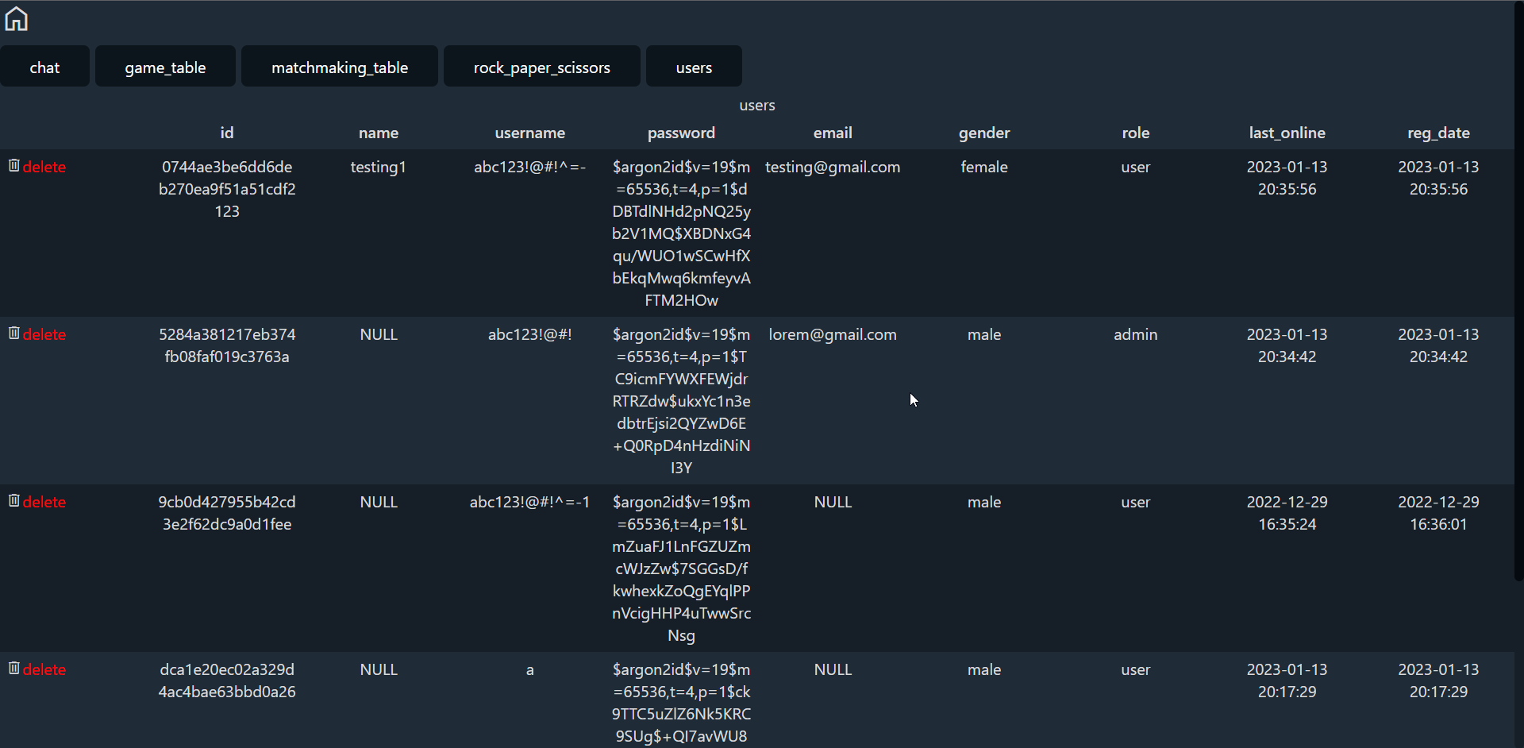

##### deleting table

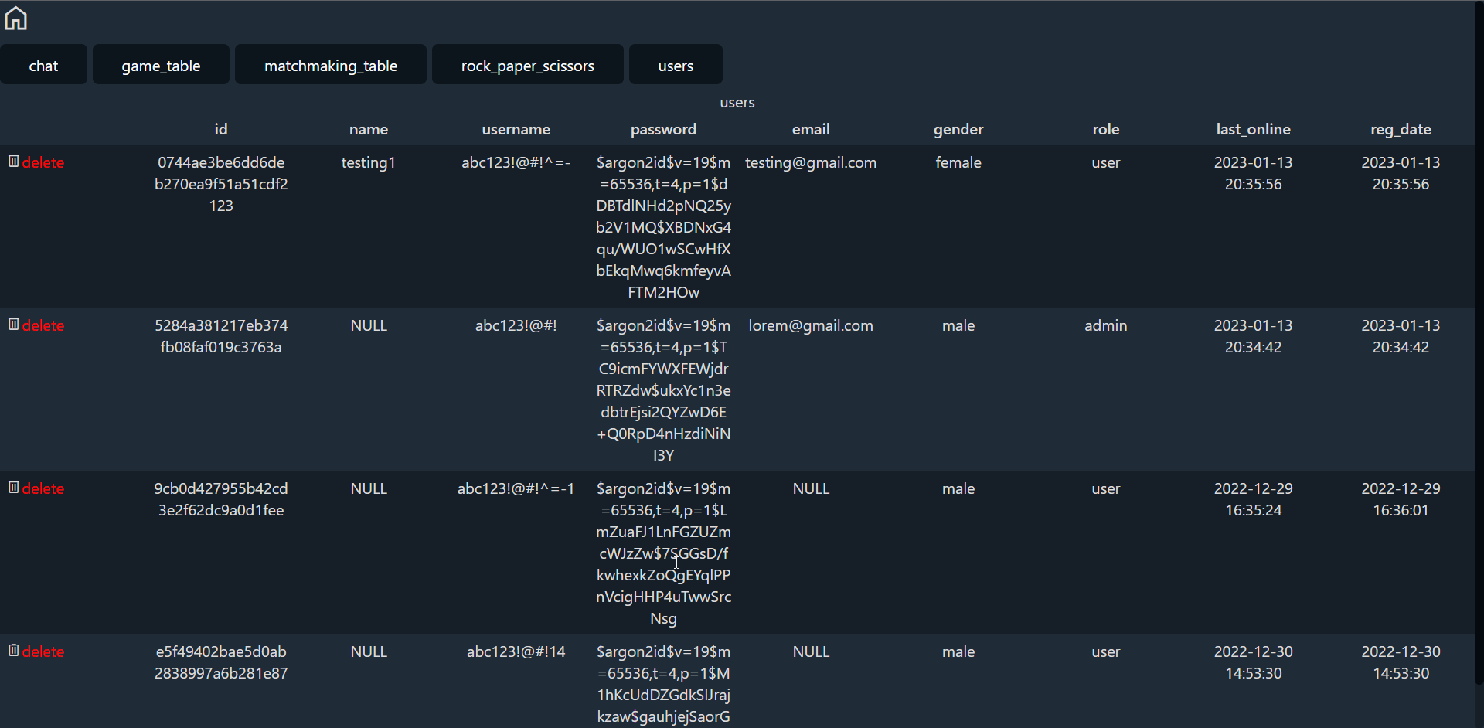

#### lobby.php



##### Entering chat





##### Choosing a game



##### Matchmaking



#### rock_paper_scissors.php

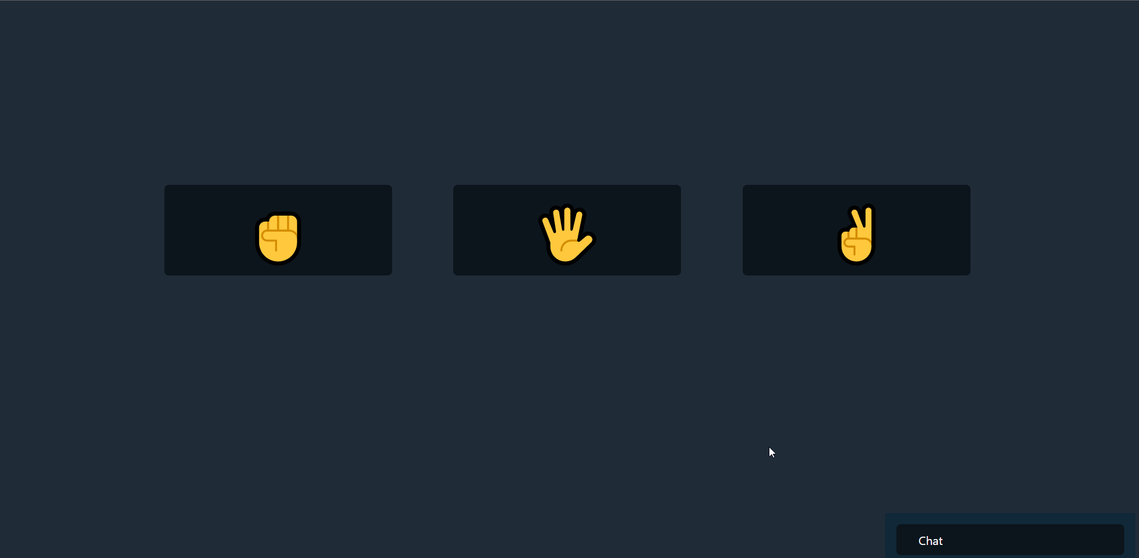

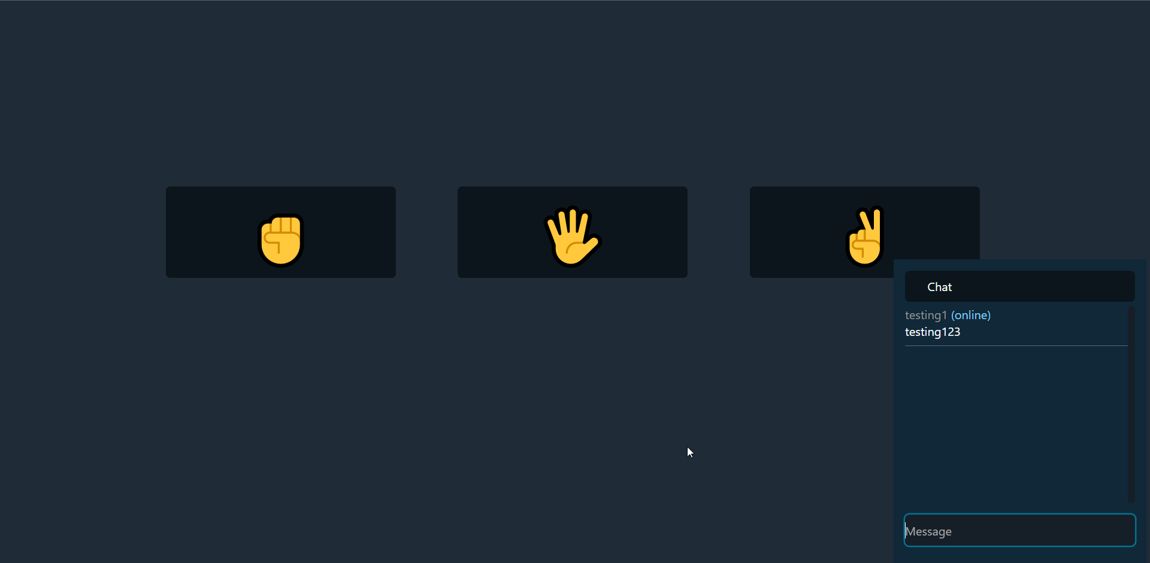

##### Waiting for opponent to make a move



##### Displaying win/lose status







##### Display win/lose & redirect after match concluded(one of the player’s hp reached 0)





### ShootingGame

### Click on the single player game.

### Choose Shooting Game and click start game.

### First it will show the score and you need to click “Start” to start the game.

### Green circle will appear and you need to aim and shoot at it to get a point in each hit.The game has a time limit which is 30 seconds. Green circle has random horizontal velocity.

### When the time is up, it will show your final score.

### **Conclusion**

This project demonstrates some of the possibilities of ajax, and that it is possible to create a dynamic web page that simulates a real time environment. By querying the database/server periodically, one can achieve the effect of real time. It’s feasible to apply this technique in various fields, such as chat applications, matchmaking, information verification/retrieval or even a multiplayer game system. Doing so will decrease the time spent reloading the web page, thus increasing the user experience.

### **Video Demo**

<https://youtu.be/Pz5rPK7DtFE>